Assembling the BEST IR Circuit Boards

These are step-by-step instructions showing how to solder the components onto the printed circuit boards (PCBs) for the BEST IR system. It assumes you already know how to solder thru-hole components. There are many “How to Solder” tutorials available on the internet so that will not be covered here.

Keep in mind that soldering components to a PC board is pretty easy but *fixing mistakes* after a component is soldered *is very difficult*. Follow a rule similar to the “measure twice, cut once” rule carpenters use. Check orientation, insert component, double check orientation, then solder.

# A few words about Electrostatic Discharge, or ESD

Have you ever walked across a room and gotten a spark when you touched a doorknob? Yes? I thought so. That spark is electrostatic discharge. You build up a charge as you walk, which discharges to the first metal thing you touch. You don’t have to be walking, just turning or sliding in your chair can build up a charge.

Some electronic components can be damaged by these discharges. A discharge *you can’t even feel* is enough to cause damage so you might not realize it is happening. Three of the components used in our IR circuit are considered ESD sensitive and should be handled with care. They are the IR LED, in the clear plastic package with 2 leads, the IR RCVR IC, in the dark plastic package with 3 leads, and the 7555 timer IC, in the 8 pin DIP. Here is a photo to help you identify them:

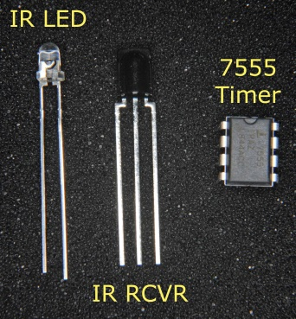

Components sensitive to ESD

The IR kit is distributed in a silvery static shielding bag. Try to keep each of these three components in the bag until you are ready to solder it onto the PC board. Once they are soldered onto the board they are pretty safe. The rest of the components are not sensitive to static discharges and may be removed from the bag at any time.

# A few words about component orientation

Some of the components used are polarity sensitive, others are not. It is critical that the polarity sensitive components are oriented correctly on the board. If they are not oriented correctly either the finished board will not work (best case) or the component will be destroyed (worst case).

If a component is flagged as polarity sensitive take an extra moment to double check the orientation and that each pin is in the correct hole before soldering.

# Needed equipment:

* + Soldering iron, 30-40 watts or temperature controlled. The tip should be no larger than 1/8” diameter, with a chisel or conical tip. Plated tips usually last longer than non-plated tips.
  + Damp sponge or other tip cleaner
  + Solder. Tin-lead is recommended since it is easier to get good joints than using lead-free solder. 60-40 tin-lead is fine but goes thru a “plastic” phase for a second while cooling, take care that nothing moves during the plastic phase. 63-37 tin-lead goes directly from liquid to solid so there is less chance of a poor solder joint. Small diameter, less than 0.030”, is best because our joints are small. FYI I use 63-37 tin-lead, 0.025” solder.
  + Small wire cutters
  + Something to hold the small PC board while you solder. This could be as simple as a “bulldog clip” (for papers) fastened at the edge of a piece of wood.
  + Multimeter (optional, for checking component values)

If you are experienced assembling PCBs you can probably get by with the “Summary” section of each step. If you are new to building PCBs or just want more information read the “The Long Version” section of each step.

# 1. The Printed Circuit Board(s)

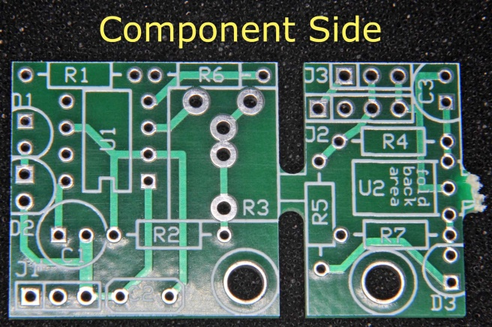 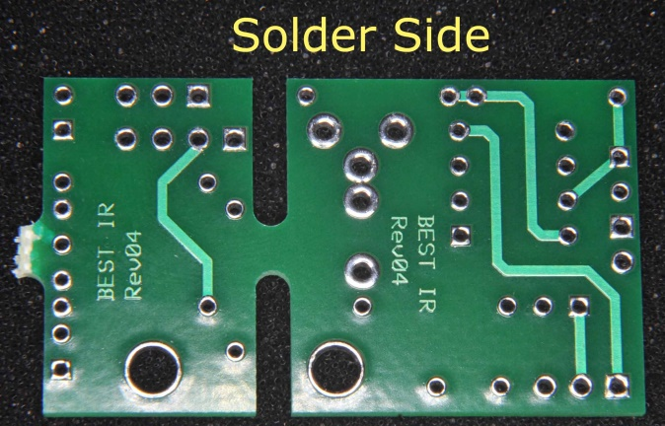

Figure 1a, component side Figure 1b, solder side

Here are two views of the bare printed circuit board (PCB). The silver holes and green traces are the connections printed onto the fiberglass. The green color is a solder mask which helps keep your added solder only in the silver areas, reducing the chance of a short circuit between adjacent connections. The two large holes near the bottom are for mounting to your robot using a #4 screw.

Figure 1a on the left is the top side, also known as the component side. It is from this side that you will insert the leads of all the components.

Figure 1b on the right is the bottom side, also known as the solder side. After inserting a component you will flip the board over and solder the leads to the board on this side.

The PCB as shown is actually two PCBs. Notice the two slots near the middle of the PCB. Looking at figure 1a, the IR transmitter PCB is the larger part to the left of the slots. The receiver PCB is the smaller part to the right of the slots. The narrow fiberglass “bridge” connecting the two parts is where the two PCBs will be separated after you finish soldering on all the components. Keeping the two PCBs as one helps during assembly because one larger PCB is easier to handle than two smaller PCBs. Unbroken the combined PCB is still only 1.65” x 0.95”. Not to worry, there is generous room around the components. ☺

# 2. Add the Six Resistors

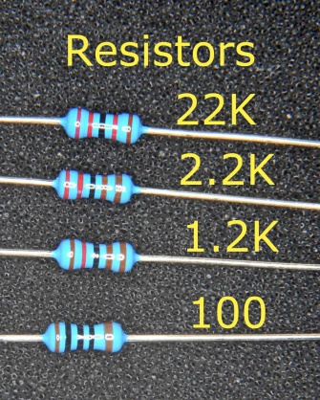 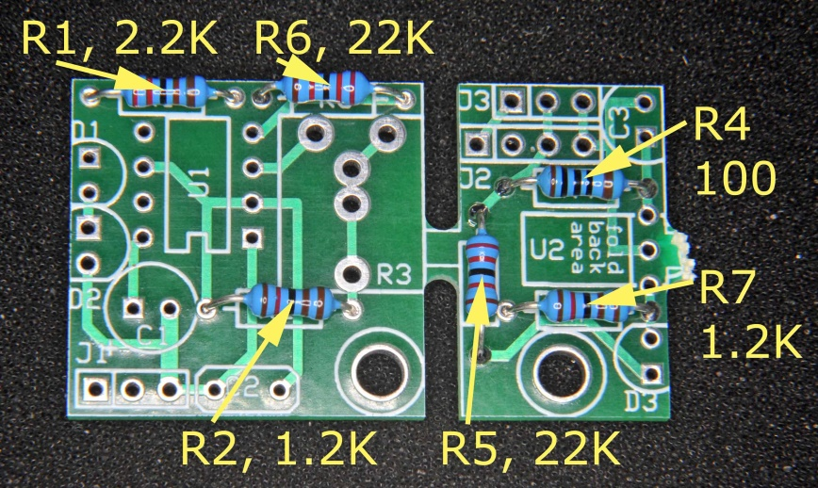

Figure 2a, sample resistors Figure 2b, resistor locations

Summary: Solder the six resistors to the PCB in the locations pictured. Make sure R6 is touching the board so it doesn’t block the adjustment of R3, installed later.

The Long Version:

Resistors come in many different values. Four different values of resistor are used in this circuit. *It is important to use the correct resistor value in each location.* If you mix up the resistors the circuit will not work.

The value of each resistor is printed on it using a “color code”. <https://en.wikipedia.org/wiki/Electronic_color_code>

Examples of the four resistor values we will use are shown in the left photo. In this photo the color bands are read from left to right. The four values are:

* R5, R6: 22K = 22,000 ohms, red – red – black – red, three significant digits & a multiplier
* R1: 2.2K = 2,200 ohms, red – red – black – brown, three significant digits & a multiplier
* R2, R7: 1.2K = 1,200 ohms, brown – red – black – brown, three significant digits & a multiplier
* R4: 100 = 100 ohms, brown – black – black – black, three significant digits & a multiplier
* Note: R3 is the potentiometer and is not listed here.

Discerning the different colors on the resistors can be difficult, you need to have good eyes and good light. If you are about to insert a resistor and are not *certain* of its value measure it with an ohmmeter. Resistor values vary slightly from piece to piece but will all be within 5% of the nominal value. For example, if you are measuring a 1.2K resistor your ohmmeter might read 1.15K or 1.24K. If it reads 2.1K *stop*, you have the wrong value resistor.

Resistors do not have a polarity and may be inserted in either of the two possible orientations.

The resistor holes are on 0.4” centers. The resistor leads will initially be straight as shown in the photo. To prepare a resistor for insertion into the PCB, hold the resistor body and loosely (not sharply) bend the leads 90 degrees at the resistor body. They should then line up fairly well with the holes. The leads are fairly bendable; you should be able to get the resistor body to set flat on the PCB. This is important for R6, if R6 is too high above the PC board it could block the screwdriver adjustment notch in potentiometer R3, which will be installed later. When the resistor is touching the PCB, hold it in place, flip the PCB over, and bend the leads about 45 degrees (sort of like a “V”) to hold the resistor in place. Solder the two leads to the PCB and cut off the excess lead length. Resistors are pretty rugged; you’ll get the hang of it.

Use figure 2b as a guide where to put each value of resistor. To reduce the chance of confusion I recommend you insert one value at a time, first the 100 ohm resistor, then the two 1.2K resistors, then the 2.2K resistor, finishing with the two 22K resistors.

# 3. Add the IC Socket

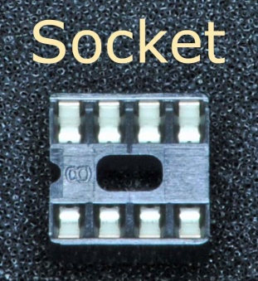 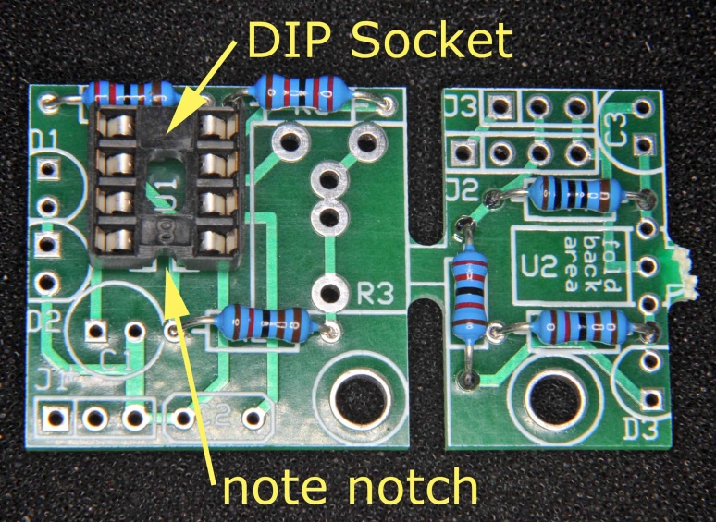

Figure 3a: IC socket Figure 3b: socket location

Summary: Solder on the IC socket. Note where the notch is.

The Long Version:

The integrated circuit (IC) used in the transmitter circuit will be mounted in a socket. This keeps the IC from being overheated from soldering it in. The socket is shown in the left photo. Note the small notch on the left end of the socket; this indicates where pin 1 of the IC should go. You can insert the IC in two orientations 180 degrees apart, only one of them is correct. Getting the socket oriented correctly now will help later with getting the IC oriented correctly.

Insert the socket into the PCB in the position shown in the right photo. Note that the notch is toward the bottom, toward the center of the PCB. The socket should sit flat on the PCB. Crooked sockets are ugly.

The socket tends to fall out of the PCB while you are trying to solder it. If the PCB is upside down on your workbench you should be OK. If the PCB is in some kind of vise or other holder, hold the socket in place with a rubber band or similar object – you’re in BEST, you can figure something out.

When you have the socket in position and are ready to solder, start by soldering *one pin* of the socket. Now check the socket to ensure it is flat on the PCB (remember, only you can prevent crooked sockets). If the socket is crooked, press on it lightly – but not over the pin you soldered or you will get burned – and use your soldering iron to reheat the pin you soldered. The socket should “snap” into place as soon as the solder melts. Hold the socket in place 5 seconds while the solder solidifies again. This is a good time to double check that the socket is oriented correctly. If it is not, fix it now while only one pin is soldered.

Once the socket is flat on the PCB and oriented correctly go ahead and solder the other 7 pins. There is no need to trim the excess from the socket leads, they are pretty short. Double check that no pins are accidently soldered together – a solder bridge. If they are, carefully remove the bridge with your hot soldering iron. Holding the PC board solder side down and applying the tip of the iron to the solder bridge *from below the board* will usually induce the excess solder to flow onto the soldering iron (gravity is your friend). Yes, you kind of have to stand on your head to do this.

If in spite of the warning you still managed to solder the socket in the wrong orientation don’t panic. We’ll take care of it later. At this point trying to remove the 8 pin socket will almost certainly destroy the PC board.

# 4. Add the Male Connectors

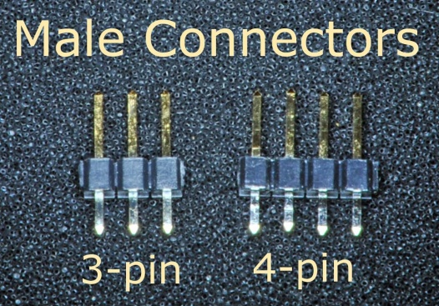 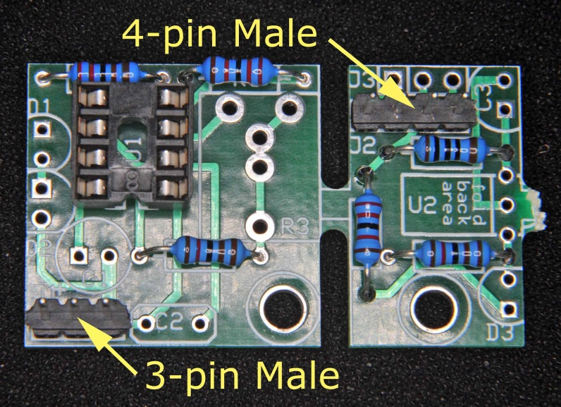

Figure 4a: male connectors Figure 4b: male connector locations

Summary: Solder on the two male pin connectors in the locations shown, long side up if one is longer than the other. Connectors may differ from photo, either gold or tin plated.

The Long Version:

The male connectors may have equal length pins on each side or a long pin on one side and a short pin on the other. The short pin (if one is shorter) gets soldered to the PCB; the long pin goes into the cable from the Cortex. The long pin may be gold or silver.

Solder the connectors into the locations shown in the figure 4b, one at a time. As with the socket, hold the connector in place using a rubber band (or some such) and solder *one pin*. Inspect the connector to make sure it is flat on the PCB and the pins are perpendicular to the PCB. If not, use the same trick of pushing it into place using another pin while you reheat the pin you soldered. After you are satisfied that the connector is straight, solder the remaining two or three pins. As you did for the DIP socket, check for solder bridges and remove if present.

# 5. Add the Female Connector

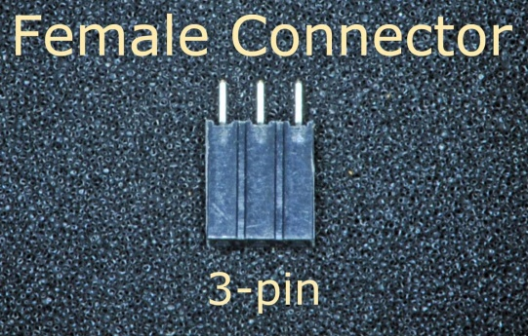 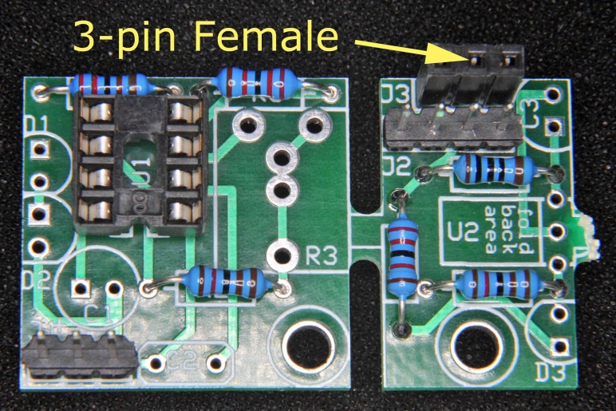

Figure 5a: female connector Figure 5b: female connector location

Summary: Solder on the female pin connector.

The Long Version:

Insert the three pins of the female connector in the location shown in figure 5b. As with the male connectors, hold it in place and solder *one pin*. The body of the female connector should be parallel to the pins of the male connector next to it. Straighten the connector if needed. Finish by soldering the remaining two pins. Check for and remove any solder bridges.

# 6. Add the Timing Capacitor

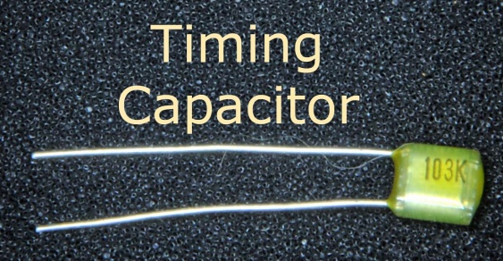 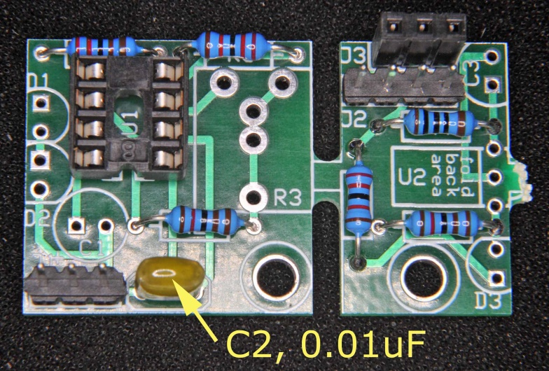

Figure 6a: timing capacitor Figure 6b: timing capacitor location

Similar to the resistors, insert the timing capacitor C2 in the location shown. Polarity is not important. After inserting the leads thru the PCB, bend them slightly to hold the capacitor in place, solder, and trim the excess lead length.

# 7. Add the Potentiometer (R3)

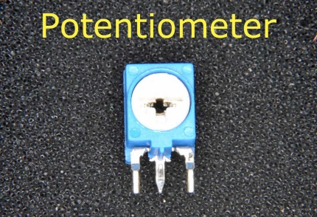 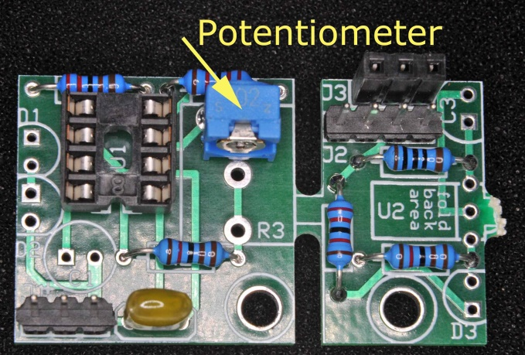

Figure 7a: potentiometer Figure 7b: potentiometer placement

The PC board has hole positions to accommodate several potentiometer options. Mount your potentiometer on the PCB using the photo above as a guide. It should “snap” into the PCB with gentle pressure and you should not need to hold it in place when soldering.

# 8. Add the Two Red LEDs {Polarity sensitive}

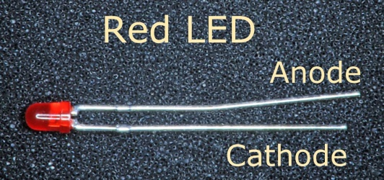 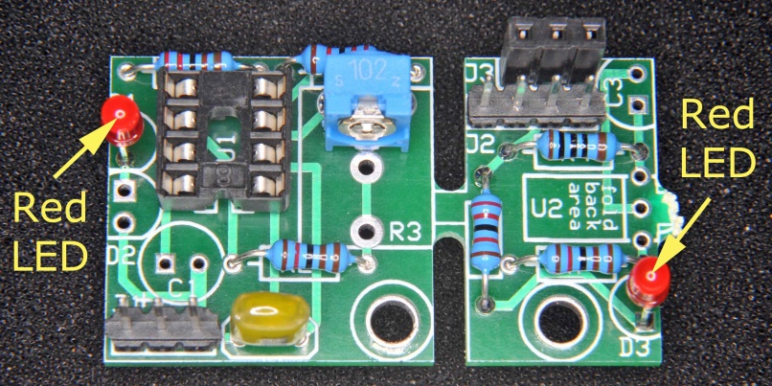

Figure 8a: red LED Figure 8b: red LED locations

Summary: Solder on the two red LEDs. The long lead goes in the hole with the square pad.

The Long Version:

Figure 8a shows one of the red LEDs, the two red LEDs are identical. An LED is **polarity sensitive** – it *must* be inserted in the correct orientation or it will not work. Notice that one lead is longer than the other. The longer lead is the anode and must be inserted into the hole that has the *square* pad around it. The shorter cathode lead is inserted in to the hole having a *round* pad around it.

Unfortunately the PCB layout ended up with the two LEDs oriented differently from each other. The LED on the left has its anode toward the top of the photo and the LED on the right has its anode toward the bottom of the photo. Pay attention to the pads when inserting the LEDs.

The red LEDs would typically be mounted as close to the PCB as possible, but you can leave some lead between the plastic LED body and the PCB if you want. This will allow you to bend the left LED toward the left or the right LED toward the right for viewing from a different direction should this be useful in your design.

Similar to the resistors, after insertion into the PCB bend the leads of the LEDs slightly to hold them in place, solder, and trim the excess lead length. You might want to solder one lead of each LED first and check that the LED is straight and inserted with the correct polarity before you solder the other lead.

# 9. Add the Infrared (IR) LED {Polarity sensitive}

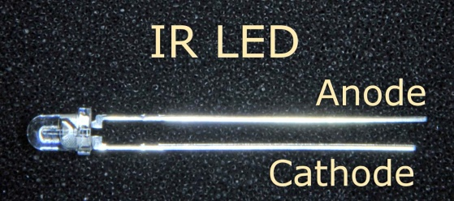 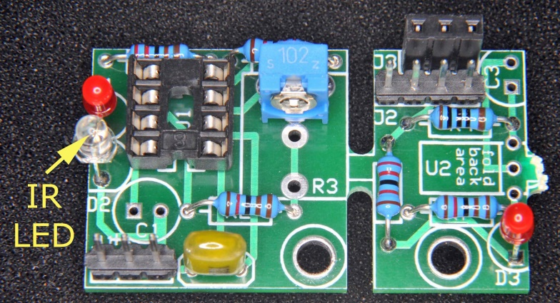

Figure 9a: IR LED Figure 9b: IR LED location

Summary: Solder on the IR LED. The long lead goes in the hole with the square pad. Leave about 0.25” lead exposed between the LED and the PCB in case you want to bend the LED over to shine in the plane of the PCB. Take precautions against static discharge when handling the IR LED.

The Long Version:

The IR LED is one of the components sensitive to static discharges. Don’t take it from the silver bag and set it down between steps. If you remove it from the bag with one hand, pick up the PC board with your other hand, and insert the IR LED into the holes on the PC board you should be fine.

The IR LED is the clear one. Like the red LEDs it is **polarity sensitive** and must be mounted to the PCB with the long lead (anode) in the hole with the square pad and the short lead (cathode) in the hole with the round pad. (If you look closely you will see that the base of the clear plastic also has a flat on the cathode side.)

Leave about 0.25” of lead exposed between the plastic body and the PCB. As shown in figure 9b the IR beam is emitted perpendicular to the plane of the PCB. Leaving the extra lead will allow you to bend the IR LED to the left so the IR beam is emitted to the left, parallel to the plane of the PCB. Note, though, that the LED leads do not like to be bent. They will fatigue rapidly, breaking after 3 or 4 bends. Try not to change your mind if you bend them.

Similar to the resistors, after insertion into the PCB bend the leads of the IR LED slightly to hold it in place, solder, and trim the excess lead length. You might want to solder one lead first and check that the LED is straight and inserted with the correct polarity before you solder the other lead.

# 10. Add the Electrolytic Capacitor {Polarity sensitive}

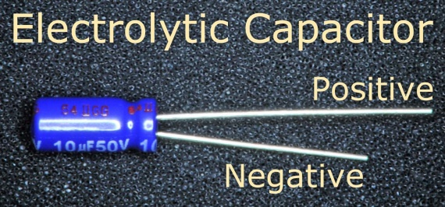 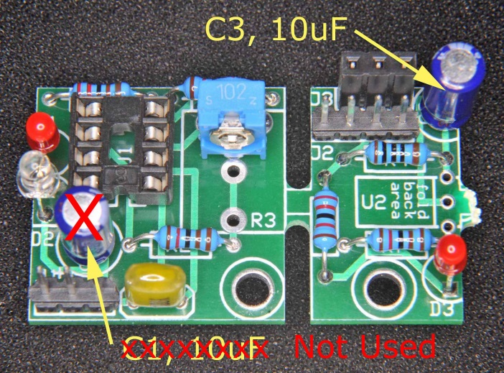

Figure 10a: electrolytic capacitor Figure 10b: electrolytic capacitor locations

Welcome to the world of ECNs – Engineering Change Notices. After using the IR system for a couple years we decided it was easier to use if there was no electrolytic capacitor on the transmitter board (we still like it on the receiver board). Therefore C1 has been removed from the kit and is no longer to be used on the circuit board. Notice it is crossed out with a large “X” in the photos in the rest of the document.

Summary: Solder on the single 10 uF bypass capacitor labeled “C3” in the photo. The positive lead goes in the hole with the square pad.

The Long Version:

Figure 10a shows an electrolytic capacitor. Electrolytic capacitors are also **polarity sensitive** and could be destroyed if voltage is applied with the wrong polarity. Once again the long lead is the positive terminal and goes into the hole having a square pad. The shorter lead is the negative terminal and goes into the hole having a round pad. (The negative lead is also marked on the case with a white stripe containing a “-“, negative sign.)

Insert the capacitor in the location labeled “C3” in the photo. After insertion into the PCB bend the leads apart slightly to hold the capacitor in position, double check that the polarity is correct, solder, and trim the excess lead length.

# 11. Add the Infrared Receiver IC {Polarity sensitive}

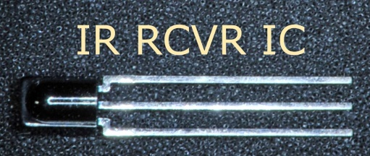 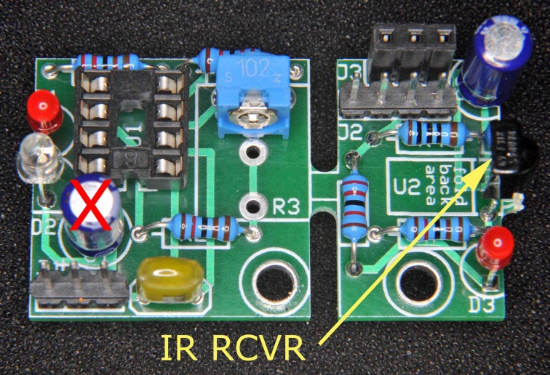

Figure 11a: IR receiver IC Figure 11b: IR receiver IC location

Summary: Solder in the IR receiver IC. The bump on the package goes toward the PCB edge. Leave about 0.25” of lead exposed between the IC package and the PCB in case you want to bend the receiver back to look up from the PCB. Take precautions against static discharge when handling the IR receiver.

The Long Version:

The IR receiver is one of the components sensitive to static discharges. Don’t take it from the silver bag and set it down between steps. If you remove it from the bag with one hand, pick up the PC board with your other hand, and insert the IR RCVR IC into the holes on the PC board you should be fine.

Figure 11a shows the infrared receiver IC. The dark plastic package is hard to see against the black background, but if you look closely you can see that it has a pronounced bump on one side. This bump is actually a lens which focuses the received IR light onto the detector chip.

The IR receiver IC is **polarity sensitive** and must be installed in the correct orientation. As shown in figure 11b the bump is on the right side, the bump actually hangs over the edge of the PCB a little. If the bump is toward the center of the PCB the IC *is installed backwards* and you can kiss it goodbye as soon as power is applied. Fix it now.

As you did with the IR LED, leave about 0.25” of lead between the plastic package and the PCB. As shown in the photo the IR receiver IC is “looking” to the right in the plane of the PCB. The extra lead allows you to bend the IC back toward the center of the PCB so it will be “looking” up, perpendicular to the plane of the PCB. This may be useful in your application. Again, the leads fatigue quickly so try not to change your mind after bending them.

# 12. Add the 7555 CMOS Timer IC {Polarity sensitive}

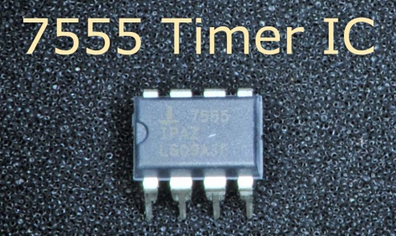 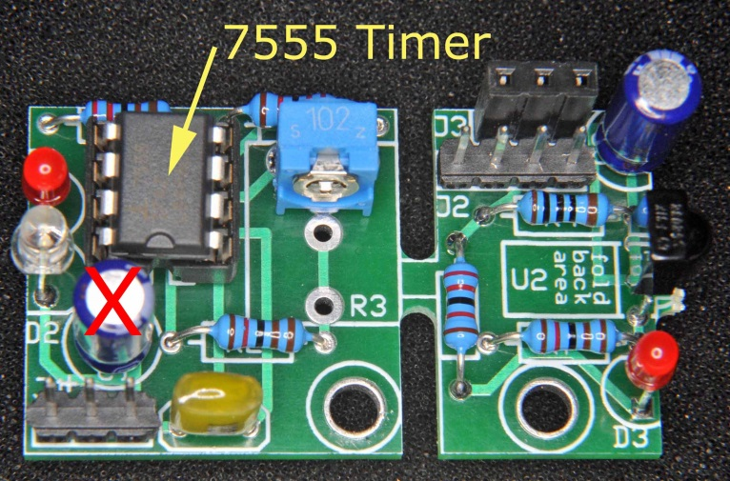

Figure 12a: 7555 timer IC Figure 12b: 7555 timer IC location and orientation

Summary: Plug the 7555 into the socket. Note where the notch goes. Take precautions against static discharge when handling the 7555 timer.

The Long Version:

The 7555 timer is one of the components sensitive to static discharges. Don’t take it from the silver bag and set it down between steps. If you set the 7555 timer down then when you move you could become charged. It doesn’t take much movement, just sliding your arm across the workbench or shifting in your chair is enough. When you reach to pick up the 7555 timer you will discharge to it, which could damage it. If you remove the 7555 timer from the bag with one hand, keep it in your hand while adjusting the pins, then pick up the PC board with your other hand and insert the 7555 timer into the socket you should be fine. This way you and the timer are always at the same voltage, so no discharges.

The last thing to add is the 7555 timer IC. It is in a Dual Inline Package (DIP) as shown in figure 12a. As you might expect by now, this IC is **polarity sensitive**, so pay close attention. On the left edge of the package you can see a small notch or dimple molded into the plastic. This indicates the location of pin 1, the pin in the lower left in the photo. The other pins are numbered consecutively going counterclockwise around the package so pins 1 thru 4 are on the bottom of the photo and pins 5 thru 8 are on the top of the photo.

If you examine the DIP package you will see that the 8 pins are bent to angle slightly outward. This makes it tricky to get all the pins into the socket because the ends of the pins are too far apart for the socket. You can simplify matters by carefully bending each pin a little more so it is bent 90 degrees. If you do so the ends of the pins will fit right into the socket.

OK, let’s plug the IC into the socket. Look at figure 12b to see that the notch on the end of the IC package is toward the center of the PCB, not toward the edge of the PCB. In the photo you can see that the notch on the 7555 timer matches the notch on the socket. If you managed to solder your socket in wrong-way-round don’t worry. Just make sure the IC is plugged in with the notch as shown, it will still fit into the socket but the two notches won’t match. The important thing is that the *IC itself* is oriented correctly.

When you have the IC properly oriented set it lightly into the socket. Visually check each pin to make sure it is lined up with its socket receptacle. If every pin looks good, press the IC into the socket. It is OK to put your thumb on top of the IC and your index finger on the bottom of the PCB under the socket, and then squeeze. When fully inserted the bottom of the IC package will touch the plastic of the socket.

# 13. You’re done! It is time to break it. Say what?!?

At this point you have completed assembling both the IR transmitter and the IR receiver. The PCBs of the two circuits are connected together by the narrow bridge of PCB material. The simplest way to separate the two boards is to cut this bridge using your wire cutters. Take your time and nibble away from each side. If you cannot reach far enough to cut completely thru the fiberglass you can probably finish by flexing the board at the now narrower bridge. You may have to flex back and forth a few times but the two PCBs will separate.

You could also use a small saw. Watch out for fiberglass dust, don’t inhale it.

## Revision Notes

11Aug22: Removed C1 so transmitter could more easily be connected to send serial data.