BEST Logo - for quality print.tif **“The BEST experience is like an education greenhouse;**

***what happens during six weeks of competition***

***would take an entire year in the classroom*.”**

~ Science Teacher, Hoover (AL)

**Middle and High School Robotics Competition**

**Take plywood, PVC pipe of various sizes, threaded rod, a box filled with screws and other hardware, an irrigation valve cover, piano wire, aluminum paint grid, a bicycle inner tube, something called a “micro-energy chain system,” an assortment of other odds-and-ends, and give it all to a team of students with the challenge to design and build a functioning, competitive robot** ***in six short weeks.***

***What do you get?***

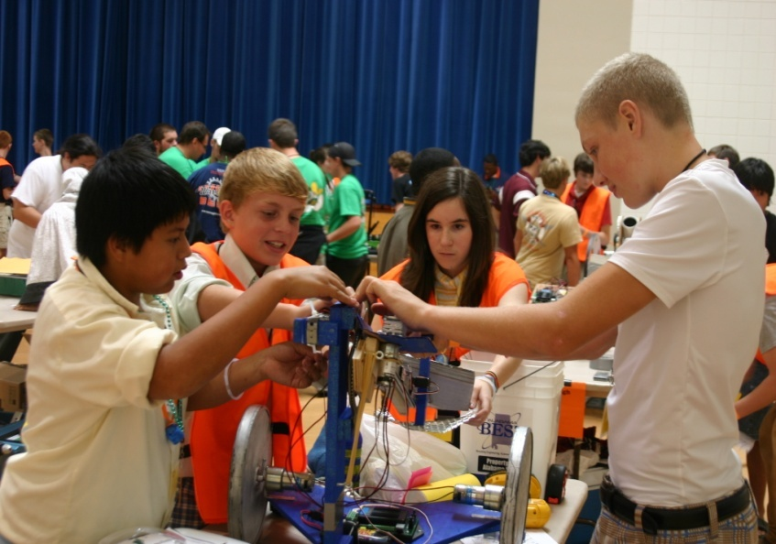

**BEST**

***Boosting Engineering,***

***Science and Technology***

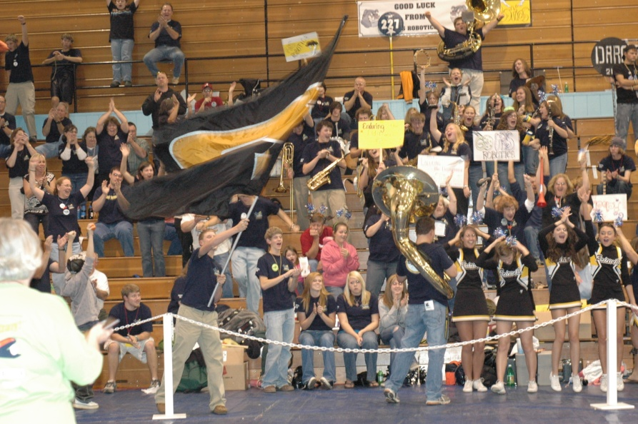

* **the *excitement* of a basketball game**
* **the *strategy* of a chess match**
* **the *intellectual challenge* of a science fair**
* **the *pressure* of a competitive sporting event**

**…plus hundreds of screaming**

**fans, pep bands, cheerleaders,**

**music, dancing, and mascots**

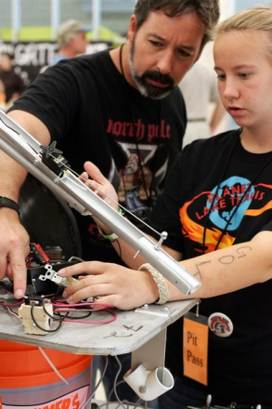

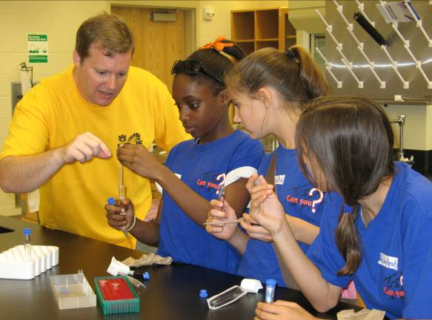

**Our mission – *to engage, excite, and inspire students* to pursue careers in engineering, science, and technology through participation in a sports-like science- and engineering-based robotics competition.**

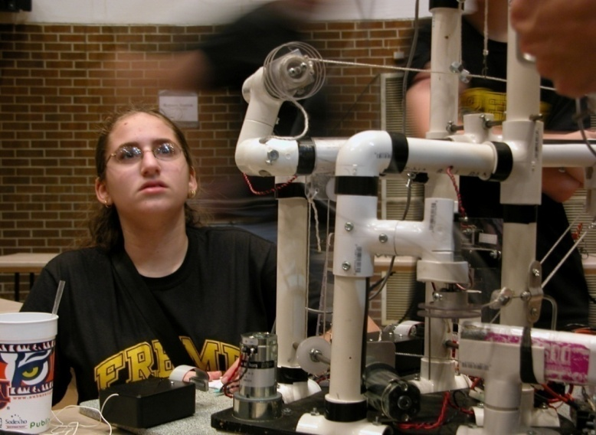

**Our Core Values**

* **Students are the sole participants and primary decision-makers, designers, and builders**
* **Any student may participate**
* **The program is free to schools—no fee**
* **Equipment and materials are provided at no cost to participating schools**
* **Any school may participate regardless of type, size, location, location, or socioeconomic status**

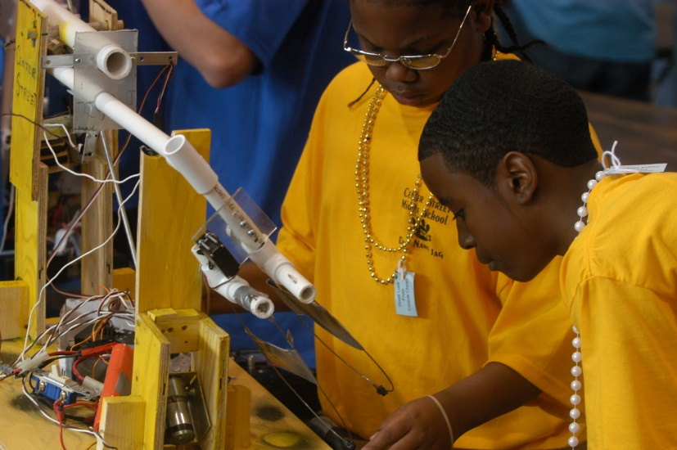

**Our Core Objectives**

* ***Provide students* with a real-world engineering experience that incorporates the practical application of math and science**
* ***Prepare students* to be technologically literate and thus better prepared to enter the workforce**
* ***Help students* develop leadership, project management, teamwork, and organizational skills**
* ***Develop students’* confidence and competence through self-directed learning, decision-making, abstract thinking, and problem-solving**

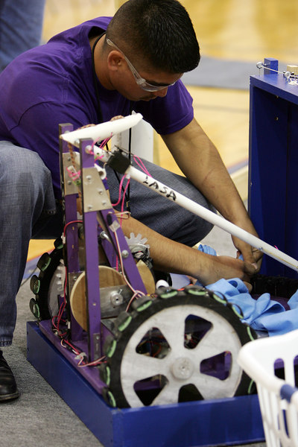

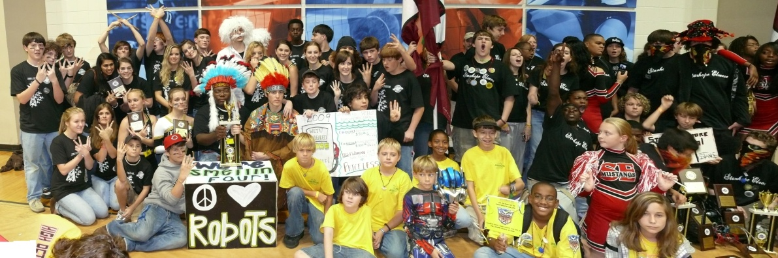

**BEST Facts**

* **1993 began as a single event for high schools in Grayson County, Texas**
* **1998 non-profit established**
* **2010 44 community-based sites in 16 states**
* **2010 Over 4000 volunteers, 850-plus schools, and 12,500-plus students**

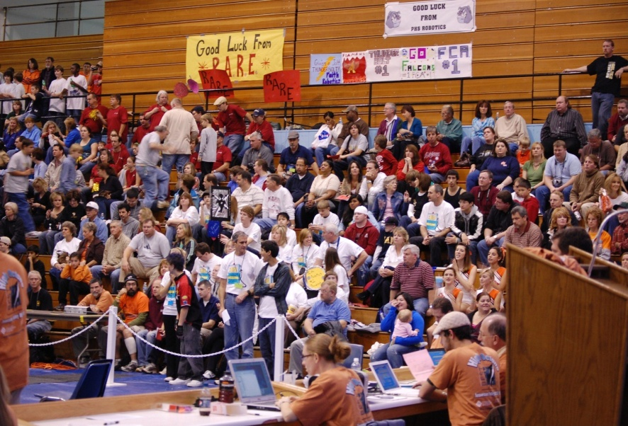

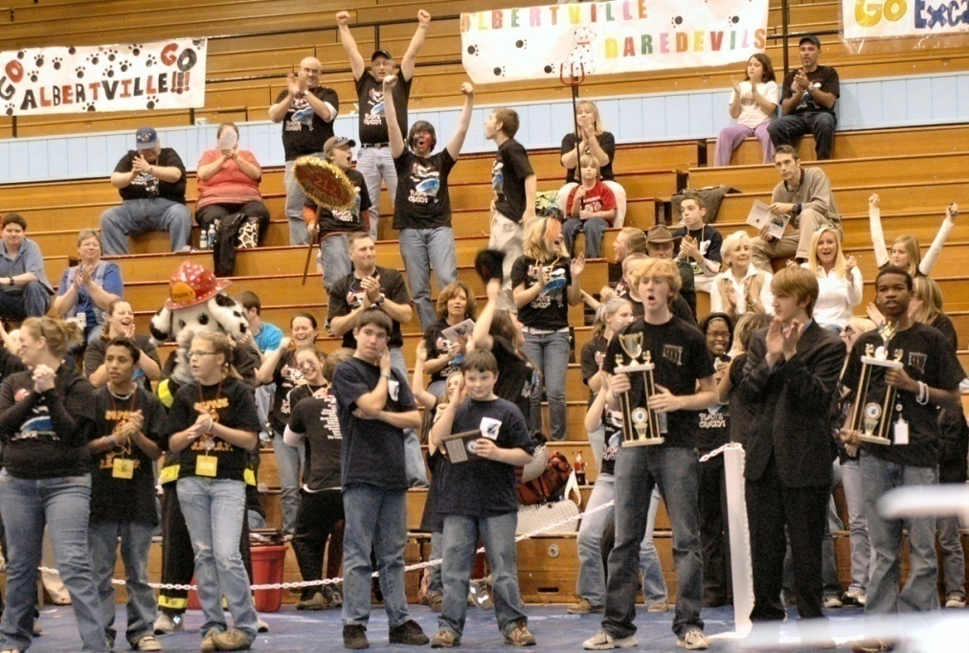

**Teams also compete in**

* **oral presentations**
* **technical writing**
* **educational exhibit design**
* **CAD design**
* **website design**
* **video production**
* **spirit and sportsmanship**

**… and more**

**“The students, parents, mentors, community, and I have become not only a team during the 42 days of BEST, but remain a team throughout the year.”**

~ Science Teacher, Mobile, AL

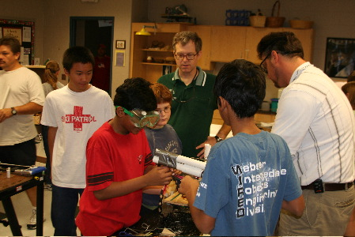

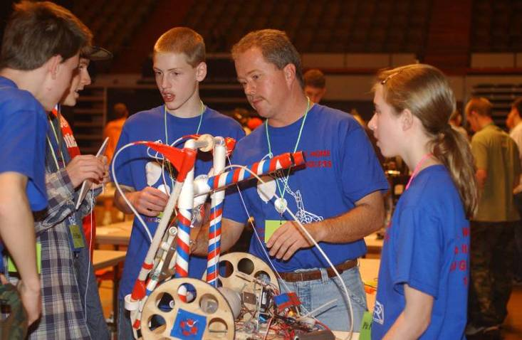

**The Engineering Design Process**

**The fundamental problem-solving tool BEST teachers and mentors use to help guide the students through the design-and-construction phase of the competition.**

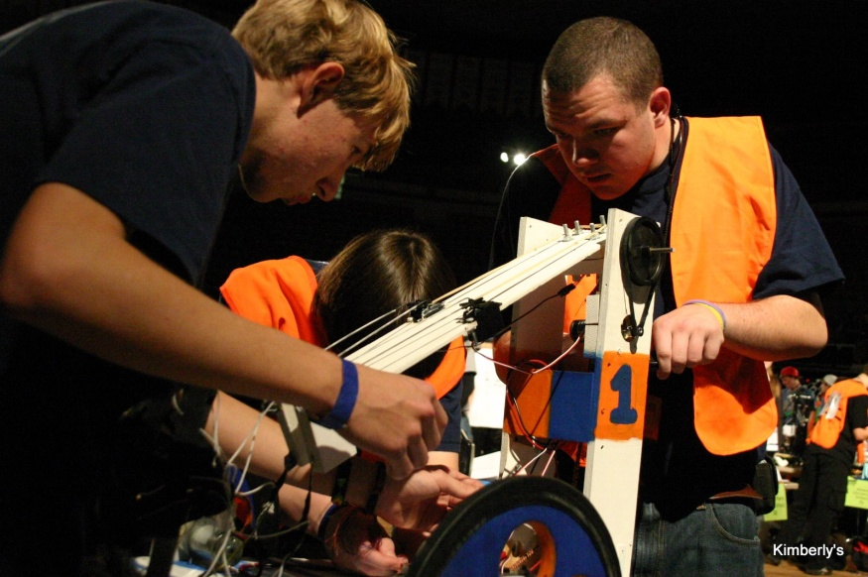

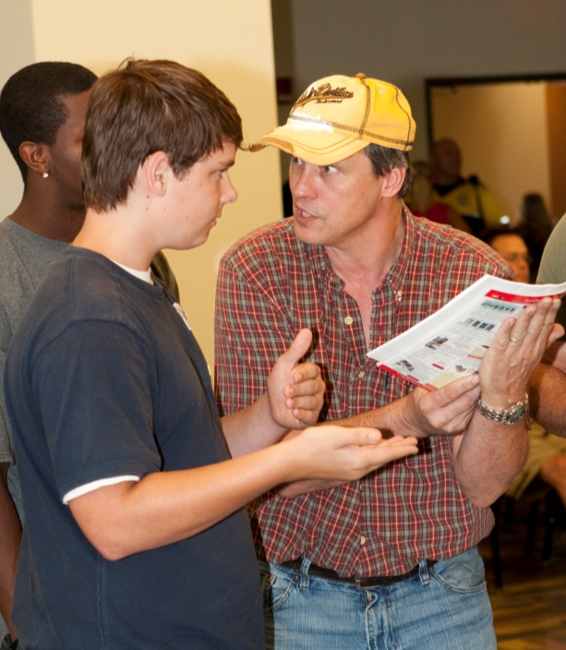

**Engineers and other technical professionals serve a vital role as team mentors, shepherding the team through the design and construction phase. By working side-by-side with an engineer from a local industry, students learn what engineers do—*engineering is “demystified.”***

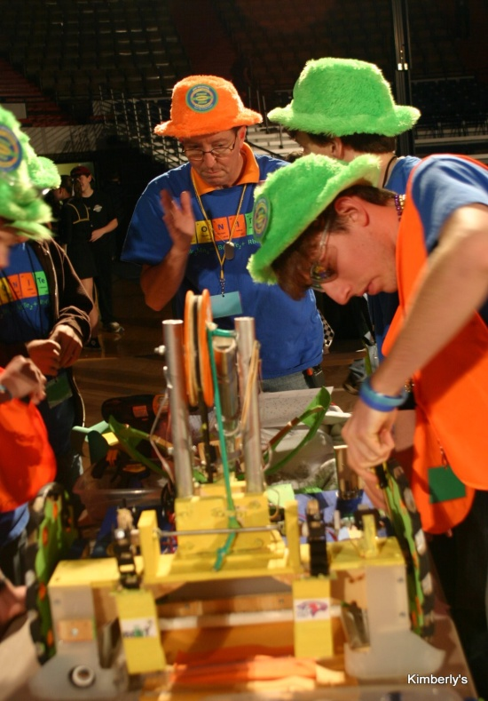

## BEST is less about building robots and more about teaching students how to analyze and solve problems. What BEST students learn is what industry needs in its future workforce and what communities need in their future leaders.

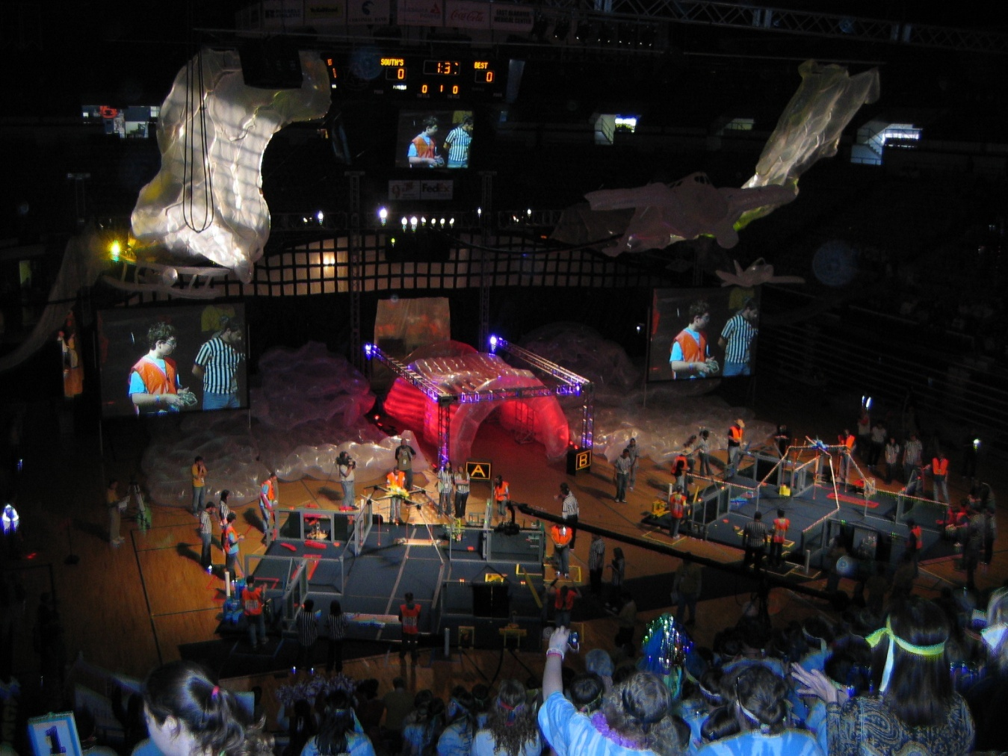

**See BEST in Action!**

[**www.bestinc.org**](http://www.bestinc.org)

**“The BEST Reason” video**

**For more information about BEST, contact:**

**Dr. George Blanks**

**Executive Director, BEST Robotics**

**and Director of K-12 Engineering Outreach**

**Samuel Ginn College of Engineering**

**217 Ramsay Hall**

**Auburn University, AL 36849**

[**blankgw@eng.auburn.edu**](mailto:blankgw@eng.auburn.edu)

**(334.703.0077)**